Java Script Engine

Java script is not any hardware it is also a program which is written in low level language.

Java script run time environment helps us use it in different places. Ex: Inside a fridge, In a TV, In a Browser, In Node.js etc.

Java script engine takes the human readable code as the input and it goes through three major steps

1. Parsing

2. Compilation

3. Execution

Parsing: During this parsing phase code is broken down into tokens

There is also something known as syntax parser which takes the input code and converts it into abstract syntax tree.

The generated AST is passed on to the compilation phase.

Compilation:

We generally write a computer program using a high-level language. A high-level language is one that is understandable by us, humans. This is called source code.

However, a computer does not understand high-level language. It only understands the program written in 0's and 1's in binary, called the machine code.

To convert source code into machine code, we use either a compiler or an interpreter.

Both compilers and interpreters are used to convert a program written in a high-level language into machine code understood by computers. However, there are differences between how an interpreter and a compiler works.

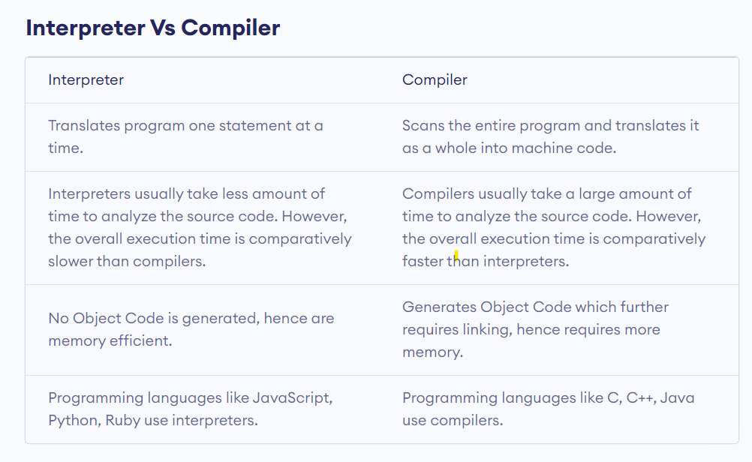

JIT(Just In Time) Compilation: If the Java script engine uses both interpreter and a compiler we call it a JIT compilation.

Execution: The code is executed in inside a call stack.

Memory heap: This is where all the memory is stored, it is constantly in sync with call stack and garbage collector.

Garbage Collector: It uses Mark & Sweep algorithm to clean up the memory space.

Compiler Optimization: In lining, copy elision, Inline caching.

Orinoco Garbage collector is used by google V8 and it uses the same Mark & sweep algorithm.

Oilpan is also a garbage collector